**CMPU2008 Human Computer Interaction Exam Replacement CA**

1. Perception, attention memory and learning are major human cognitive processes. Describe each of these

processes under the headings below and explain the impact of each process on user interface design.

Illustrate your answer with diagrams or screen shots where appropriate.

• *Perception:* Constructivist theory, Gestalt, Ecological theory

• *Attention:* Automatic processing, interruptions, multitasking, focusing

• *Memory:* Meaningfulness, familiarity, imagery, recognition and recall

• *Learning:* Mental models, metaphors,

**(25 Marks)**

**Q1.**  *Perception: The way in which a person view’s something. Perception is very important in designing webpages and other user interfaces because understanding this cognitive function can help developers create More usable interfaces.*

*For Example, The Gestalt laws tell us how people perceive images and can tell us how we can represents complex scenes with simpler shapes and structure. The gestalt laws say that Consistent design can have a person perceive separate scenes as a unified block. For example , this picture :*

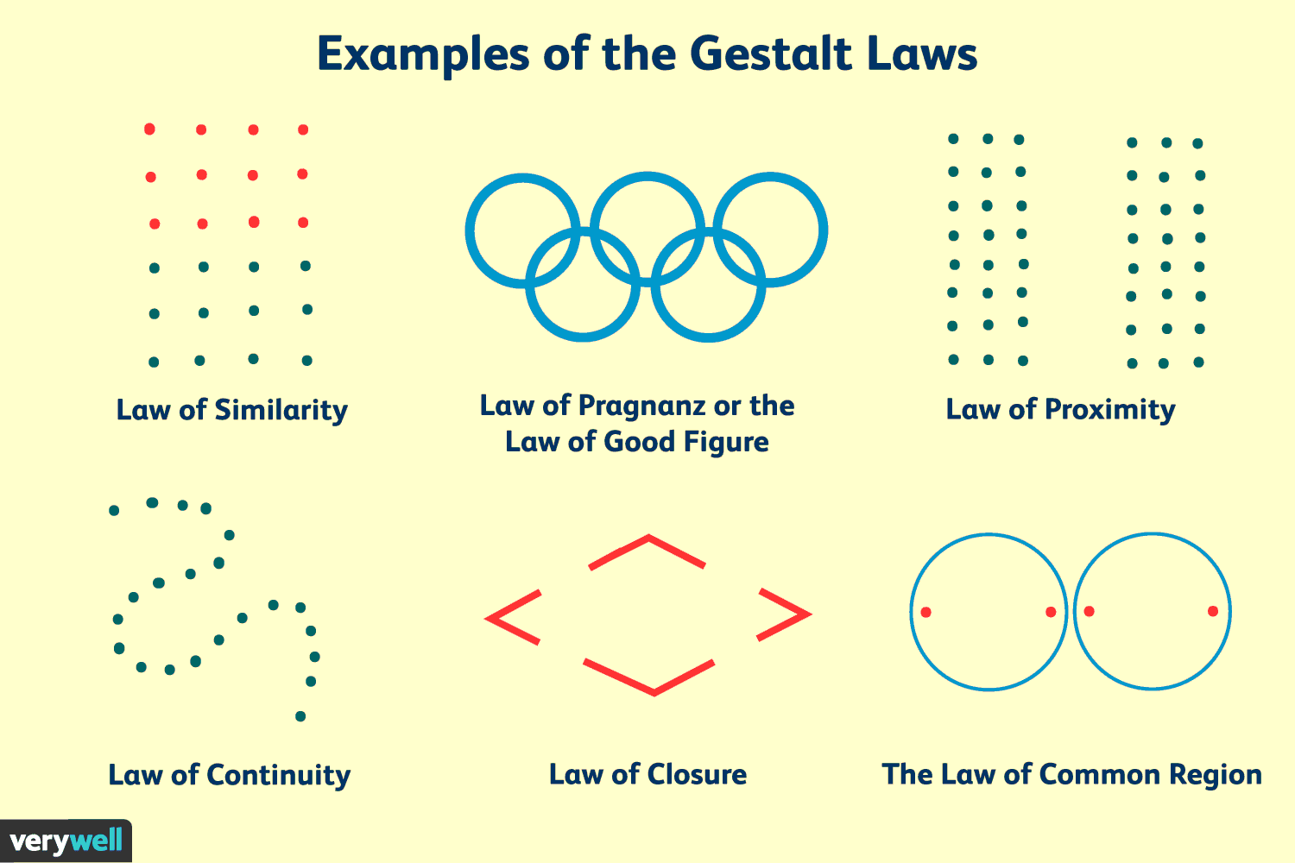

*The following picture above shows The gestalt laws in simple action. The ordering of shapes in line with the gestalt laws help us see how easy it is for us to perceive different secton of a scene. When applying such laws to web design, as developers we can create interfaces that users can very easily recognize the purpose of certain sections of an interface due to their similarity in look and or proximity to each other.*

***Attention:*** *Catching the attention of the user is very important for developers as we must make sure their focus is placed on the correct sections of an interface, we do this by creating a properly formatted interface that is not confusing or frustrating for the user to use and shows the user the relevant and most important information on the interface so it is easily used for its purpose by the user.*

*When designing an interface, it is vital that the main aspects of the interface gain the attention of the user, this is done by creating a well organised and laid out interface. With certain sections of the page well defined in contrast to other sections, defining their purpose along with it. These design methods help capture the focus of the user.*

*We must look at cognitive processes such as multitasking, we, as developers, are aware that a user regularly multi tasks. When on an interface, the user may have a primary and secondary tasks open and are in the use. It is vital for developers to make sure there is a constant difference between tasks the users may have open. This allows for the user to keep their focus on certain tasks when needed.*

**Memory:** *When it comes to the cognitive process of memory, it is vital for developers create an interface that is very memorable in short period of use time by the user. This is done through adopting multiple memory cognitive processes that help us accomplish this task.*

*The cognitive process, meaningfulness, helps us to section different tasks based on their importance and depth, with this in mind, we can pick which tasks are more important that others and put the most important tasks at the forefront of our interface.*

*Imagery is very useful when it comes to memory cognition. using icons and symbols rather than text to represent certain tasks and/or tabs in an interface makes it memorable, for example using a question mark icon like this,*



*To represent a help tab rather than text is easily recognised. It is best for developers to develop an interface which is very recognisable, based on its design, making it a lot more simpler for users to navigate and use the interface as it is intended to.*

*Learning: Developers must also take into account learning processes, we must be able to design an interface in a way that makes it easily learnable for users, in turn making the interface easier to user to use. This can be achieved through applying multiple learning cognitive functions.*

*Such a cognitive function would be metaphors, a metaphor, in human computer interaction terms, refers to methods in which we design an interface to exploit a user’s previous experience, allowing the user to learn the functions of the interface extremely quickly.*

*Another learning cognition would be errors, when looking at mistakes, we differ between mistakes and slips. mistakes are incorrect decisions based on incorrect assumptions, while a slip is an intentional mistake. Developers, when designing an interface must make sure to add error preventing measures into the interface design, this can be done through emphasizing recognition through the design, lowering the user’s likeliness to make an error.*

2. The Graphical User Interface (GUI) is one of the most common interface types in use today. Graphical

interfaces, however increase the potential for visual clutter and user confusion. From your knowledge of

HCI, describe how you would minimize visual clutter when designing GUIs. Illustrate your answer with

diagrams or screen shots where appropriate.

**(25 Marks)**

*What I would do to prevent clutter being a major issue on my GUI would be to design my GUI in a very organised way so that things do no clutter. Firstly, we must separate tasks on a GUI into separate sections and define them, ordering them in ways that prevent clutter on the GUI building up, then we use different fonts in text and image to define tasks. The main thing I would do however to prevent clutter would be to minimize the use of text.*

*The following image consists of a concept GUI I drew, based on an online pet shop concept*

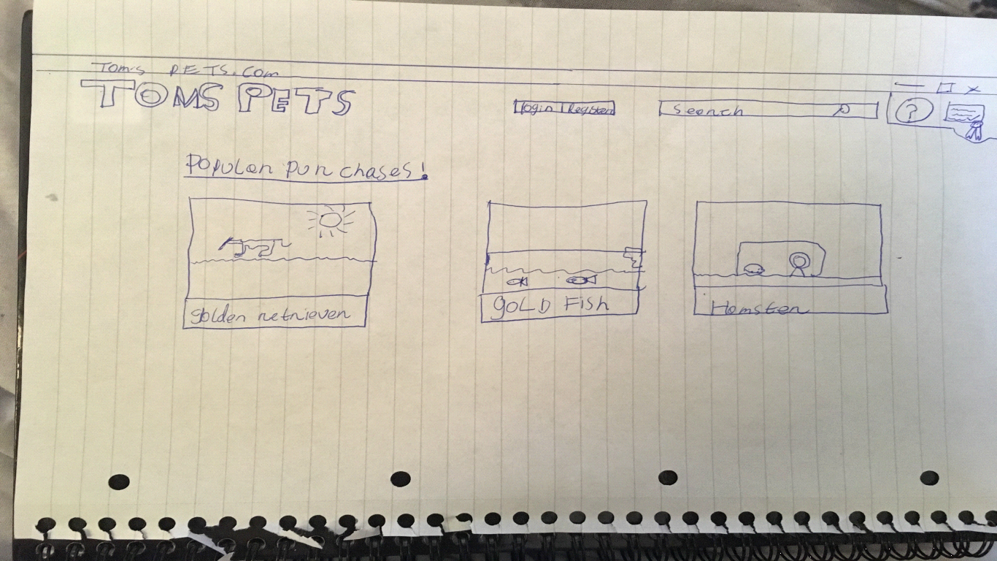

*This basic draw up demonstrates how I would design an interface with the intention of minimising clutter by spacing tasks into different section in accords to their relativity to each other. as is seen, the tabs for the tasks that would inform the user on the website, are right beside each other, and the tabs showing the popular animals are right beside each other. This simple design shows how we, as developers, can section parts of an interface so that clutter is not present.*

***Q3:*** *The website that I have chosen to analyse is* [*http://www.gatesnfences.com/*](http://www.gatesnfences.com/) *. The website is dedicated to making bookings for building gates and/or fences for homes across the state of Florida. The websites main issue is it's over use of text, there is simply too much text for the user to take in at first sight and makes the website very unappealing. The background and graphics on the website are very clunky looking also.*

*When looking at interacting with the website, I decided to first undergo the task of ordering a driveway gate. To do this, I:*

* *first clicked on driveway gate, this opened a page that showed an array of images showing me the gates*
* I then clicked on the desired drive way gate i wanted to purchase.
* this will bring you to a new tab which allows you to decided on the desired size of the gate to add to your cart.
* you are then brought to an order page where you enter your zip code.
* after you enter the checkout page where you enter your personal and account details for purchase.

The page can be seen in the following image

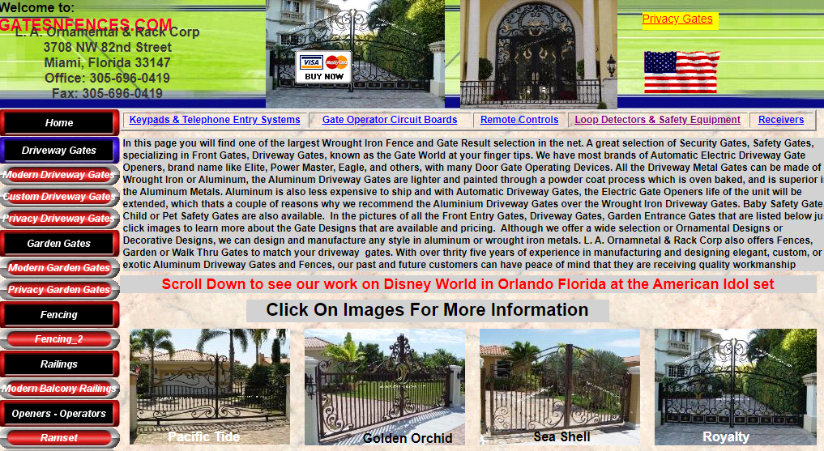

Another Task I looked at on the website was contacting the website clerk through their forum. to do this you must first:

* scroll to the bottom of the page and click on 'contact us
* fill in your details
* post on the forum and wait for a response

The third task that I looked at was the searching up an item:

* type in an item in the search bar, i.e. a fence
* resulting in many links to types of gates appearing for you to click
* I then clicked on the desired gate

The fourth and last task I took upon myself to look at was the registration form.

* you first click the dealer’s application button at the bottom of the page, this brings you to the application page.
* One would then fill in their details and submit.

The main usability issues that I noticed while browsing the website is the overuse of text and tabs on one page alone. This simply very unattractive to a user, to remove this issue, we can also reduce the amount of text on one page and put details into separate tabs.

For tabs, we can put multiple tabs on the side-line under certain tabs based on their relation to each other, for example putting all types of gates into the gate tab, on a separate page. This can make the search for products a lot more easier for users in the long run.

Another usability issue That I came across were the search bar results, there simply were too many unspecific results to go through, this simply was overwhelming. To remove this issue, when a user would enter a general search term, for example, a gate, the user would be shown links to tabs for different types of gates, rather than getting a long list of links to random gates for them to trudge through.